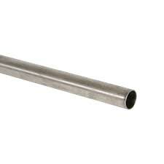
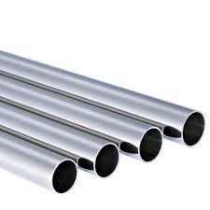

Single or layer tubes

General Information:
Company name
Person to contact
E-mail address
Phone no.
Address
Your SGM Contact | Name: | Phone no.:

Pipe specifications:
Length | Min. mm/inches | Max. mm/inches
Outside diameter (OD) | Min. mm /inches | Max. mm/inches
Wall thickness (WT) | Min. mm /inches | Max. mm/inches
Minimum possible WT that the largest pipe OD may present | Min. kg/lbs
Maximum possible WT that the largest pipe OD may present | Max. kg/lbs
Lifting mode | ◻ Single pipe | ◻ Layer of pipes
Pipe layer composition | Qty. | per OD mm/inches
Pipe layer composition | Qty. | per OD mm/inches
Pipe layer composition | Qty. | per OD mm/inches
The pipes are:
◻ Seamless
◻ Spiral welded, thickness mm/inches
◻ Longitudinal weld, thickness mm/inches
Temperature | ◻ Ambient | ◻ Hot (>150°C/300°F)
For hot pipes only
Standard surface temperature °C/°F
Maximum surface temperature °C/°F

Crane specifications:
Crane rated voltage | ◻ Vac ◻ Vdc
Crane working environment | ◻ Indoor ◻ Outdoor
Crane type and capacity
◻ Single hoist | ◻Two hoists (set distance) | ◻Two independent hoists

Capacity tons | Capacity 1 tons | Capacity 1 tons
 | Capacity 2 tons | Capacity 2 tons
Set distance
mm/inches

Remarks:
Preferred solution:
◻ Electro-magnet
◻ Electro-permanent magnet
◻ No preference
For Electro-magnet only
Battery back-up requested: | ◻ Lead Acid Type | ◻ Gel Type | ◻ Not requested
Battery back-up duration: | ◻ 20 minutes | ◻ 30 minutes | ◻ Other

Notes:

