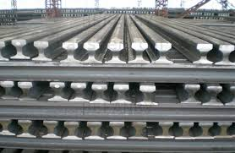

Rails

General Information:
Company name
Person to contact
E-mail address
Phone no.
Address
Your SGM Contact | Name: | Phone no.:

Rail Layer Specifications:
Please detail rail profile specification(s) as per your denomination standards:

Length(s) meters/feet
Weight(s) kg/lbs.
Rail layer composition | Qty. | per profile mm/inches
Rail layer composition | Qty. | per profile mm/inches
Rail layer composition | Qty. | per profile mm/inches
 | Qty. | per profile mm/inches
Temperature | ◻ Ambient | ◻ Hot (>150°C/300°F)
For hot rails only
Standard surface temperature °C/°F
Maximum surface temperature °C/°F

Crane specifications:
Crane model
◻ Bridge crane ◻ Double leg crane
◻ Else, please specify:
Crane rated voltage | ◻ Vac ◻ Vdc
Crane working environment | ◻ Indoor ◻ Outdoor
Crane type and capacity
◻ Single hoist | ◻Two hoists  (set distance) | ◻Two independent hoists

Capacity tons | Capacity 1 tons | Capacity 1 tons
 | Capacity 2 tons | Capacity 2 tons
Set distance
mm/inches

Remarks:
Preferred solution:
◻ Electro-magnet
◻ Electro-permanent magnet
◻ No preference
For Electro-magnet only
Battery back-up requested: | ◻ Lead Acid Type | ◻ Gel Type | ◻ Not requested
Battery back-up duration: | ◻ 20 minutes | ◻ 30 minutes | ◻ Other

Notes:

