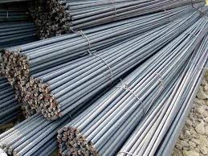

Re-bars
Reinforced construction bars

General Information:
Company name
Person to contact
E-mail address
Phone no.
Address
Your SGM Contact | Name: | Phone no.:

Specifications:
Re-bar section: max. mm | Min. mm/inches | Max. mm/inches
Bundle length | Min. mm/inches | Max. mm/inches
Bundle weight | Max. kg/lbs. | Max. kg/lbs.
Minimum possible bar section of longest bundle: |  | mm/inches
Maximum weight of the shortest bundle: |  | kg/lbs.
Minimum length of the heaviest bundle: |  | mm/inches
Max. quantity of bundles to be lifted at a time: | 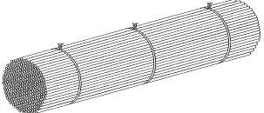
Max. width of multiple layers mm/inches
Banding
Quantity of straps: | Every m/ft (distance)
Tightness | ◻ Tight ◻ Loose and adjustable  ◻ Loose and non adjustable
Temperature | ◻ Ambient | ◻ Hot (>150°C/300°F)  Indicate Max. Temp. =
Standard quantity of lifts per hour
Maximum lifts per hour

Crane specifications:
Crane rated voltage | ◻ Vac ◻ Vdc
Crane working environment | ◻ Indoor ◻ Outdoor
Crane type and capacity
◻ Single hoist | ◻Two hoists (set distance) | ◻Two independent hoists

Capacity tons | Capacity 1 tons | Capacity 1 tons
 | Capacity 2 tons | Capacity 2 tons
Set distance
mm/inches

Remarks:
For Electro-magnet
Battery back-up requested: | ◻ Lead Acid Type | ◻ Gel Type | ◻ Not requested
Battery back-up duration: | ◻ 20 minutes | ◻ 30 minutes | ◻ Other

Notes:

