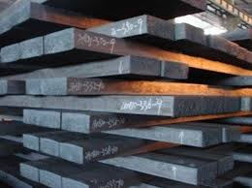
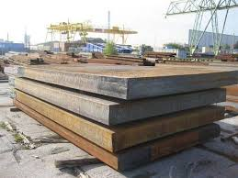

Blooms and Slabs

General Information:
Company name
Person to contact
E-mail address
Phone no.
Address
Your SGM Contact | Name: | Phone no.:

Slab/bloom specifications:
Length | Min. mm/inches | Max. mm/inches
Width | Min. mm/inches | Max. mm/inches
Thickness | Min. mm/inches | Max. mm/inches
Weight | Min. kg/lbs. | Max. kg/lbs.
Temperature | ◻ Ambient | ◻ Hot (>150°C/300°F)
For hot slabs & blooms only
Standard surface temperature °C/°F
Maximum surface temperature °C/°F
Standard time per magnet lifting cycle seconds
Magnet operating time hours/day for days/week
Slab caster capacity per hour (8 hours) tons/US tons

Crane specifications:
Crane rated voltage | ◻ Vac ◻ Vdc
Crane working environment | ◻ Indoor ◻ Outdoor
Crane type and capacity
◻ Single hoist | ◻Two hoists (set distance) | ◻Two independent hoists

Capacity tons | Capacity 1 tons | Capacity 1 tons
 | Capacity 2 tons | Capacity 2 tons
Set distance
mm/inches

Remarks:
Preferred solution:
◻ Electro-magnet
◻ Electro-permanent magnet
◻ No preference
For Electro-magnet only
Battery back-up requested: | ◻ Lead Acid Type | ◻ Gel Type | ◻ Not requested
Battery back-up duration: | ◻ 20 minutes | ◻ 30 minutes | ◻ Other
Lifting area environment:
◻ Slab yard
◻ Truck or railcar loading
◻ Vessel loading
◻ Else

Notes:

