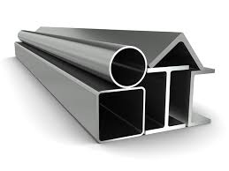
Structurals
in bundles and packs

General Information:
Company name
Person to contact
E-mail address
Phone no.
Address
Your SGM Contact | Name: | Phone no.:

Structural specifications:
◻ 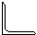 ◻ ◻ 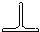 ◻ 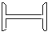

◻ 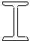 ◻ ◻ 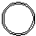 ◻
◻ Profile section: max. mm | Min. mm/inches | Max. mm/inches
◻Various:

Bundles
Diameter | Min. mm/inches | Max. mm/inches
Length | Min. mm/inches | Max. mm/inches
Weight | Max. kg/lbs.
Max. quantity of bundles to be lifted at a time: | 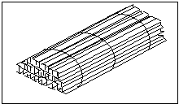
Max. width of multiple bundles mm/inches
Banding
Quantity of straps: | Every m/ft (distance)
Tightness | ◻ Tight ◻ Loose and adjustable  ◻ Loose and non adjustable
Temperature | ◻ Ambient | ◻ Hot (>150°C/300°F)  Indicate max. temp.=

Packs
Section width | Min. mm/inches | Max. mm/inches
Section height | Min. mm/inches | Max. mm/inches
Section length | Min. mm/inches | Max. mm/inches
Section weight | Max. kg/lbs.
Maximum weight of the shortest pack kg/lbs.
Number of packs to be lifted at a time
Maximum width of multiple packs mm/inches
Banding
Quantity of straps: | Every m/ft (distance)
Tightness | ◻ Tight ◻ Loose and adjustable  ◻ Loose and non adjustable
Temperature | ◻ Ambient | ◻ Hot (>150°C/300°F)  Indicate max. temp.=

Crane specifications:
Crane rated voltage | ◻ Vac ◻ Vdc
Crane working environment | ◻ Indoor ◻ Outdoor
Crane type and capacity
◻ Single hoist | ◻Two hoists (set distance) | ◻Two independent hoists

Capacity tons | Capacity 1 tons | Capacity 1 tons
 | Capacity 2 tons | Capacity 2 tons
Set distance
mm/inches

Remarks:
Preferred solution:
◻ Electro-magnet
For Electro-magnet
Battery back-up requested: | ◻ Lead Acid Type | ◻ Gel Type | ◻ Not requested
Battery back-up duration: | ◻ 20 minutes | ◻ 30 minutes | ◻ Other

Notes:

