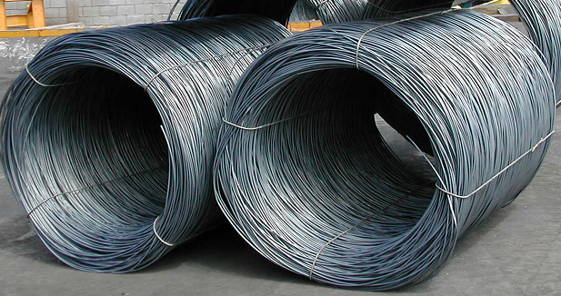
Wire rolls

General Information:
Company name
Person to contact
E-mail address
Phone no.
Address
Your SGM Contact | Name: | Phone no.:

Specifications:
Length | Min. mm/inches | Max. mm/inches
Inner diameter | Min. mm/inches | Max. mm/inches
Outer diameter | Min. mm/inches | Max. mm/inches
Wire section | Min. mm/inches | Max. mm/inches
Weight | Min. kg/lbs. | Max. kg/lbs.
Temperature | ◻ Ambient | ◻ Hot (>150 °C / 300 °F)
For hot coils only
Standard surface temperature °C/°F
Maximum surface temperature °C/°F

EMBED MSPhotoEd.3 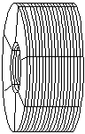 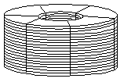
◻ Horizontal eye ◻ Vertical eye

Banding
Type | ◻ Straps ◻ Wires
Tightness | ◻ Tight ◻ Loose and adjustable  ◻ Loose and non-adjustable
Maximum quantity of rolls to be lifted at a time:
For multiple roll-lift only
Maximum quantity of rolls per length | Qty. x length
Rolls to be lifted are positioned | ◻ in a row ◻ side by side

Crane specifications:
Crane capacity tons/US tons
Crane rated voltage | ◻ Vac ◻ Vdc
Crane working environment | ◻ Indoor ◻ Outdoor

Remarks:
Electro-magnet
Battery back-up requested: | ◻ Lead Acid Type | ◻ Gel Type | ◻ Not requested
Battery back-up duration: | ◻ 20 minutes | ◻ 30 minutes | ◻ Other

Notes:

